**P210/6**

**HISTORY**

**(African History)**

Paper 6

Jul/Aug 2019

3 Hours

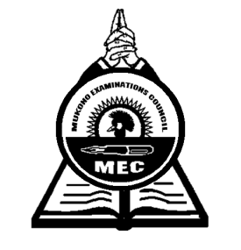

**MUKONO EXAMINATION COUNCIL**

**Uganda Advanced Certificate of Education**

**HISTORY**

**(African History)**

Paper 6

3 Hours

**INSTRUCTIONS TO CANDIDATES**

*Answer any* ***four*** *questions only*

*All questions carry equal marks.*

*Any additional question(s) attempted will not be marked.*

1. Assess the role of the military sector in the survival and maintenance of the pre-colonial African states by the end of the 19th century. ***(25 marks)***
2. To what extent was the Berlin colonial congress of 1884 – 1885 responsible for the scramble and partition of Africa? ***(25 marks)***
3. Examine the impacts of the Abolition of slave trade in West Africa. ***(25 marks)***
4. How did the Portuguese rule affect the people of Angola by the end of the 19th century?

***(25 marks)***

1. Explain the challenges that undermined the work of Ajaji Crowther as a missionary in West Africa. ***(25 marks)***
2. Account for the adoption and success of indirect rule in Northern Nigeria. ***(25 marks)***
3. Justify the causes and consequences of the Temne- Mende rebellion of 1898. ***(25 marks)***
4. Examine the impact of the mineral revolution to the peoples of South Africa between 1867 and 1910. ***(25 marks)***
5. How did the British exploit African land upto 1914? ***(25 marks)***
6. Why was Omukama Kabalega able to resist the British for long? ***(25 marks)***

***End -***